**SIMIYU JOY ABIGAEL – 120**

**PRACTICAL ACTIVITY 4:**

**Email:** [**joy.simiyu@womentechsters.org**](mailto:joy.simiyu@womentechsters.org)

**Write a shell script to validate password strength when a user enters. Here are a few assumptions for the password string.**

* Length – minimum of 8 characters.
* Contain both alphabet and number.
* Include both the small and capital case letters.

If the password doesn’t comply with any of the above conditions, then the script should report it as a <Weak Password> if the password complies with the conditions, it should echo <Strong Password Secure User>

* Created a file called practical2.sh where I wrote the code as shown below.

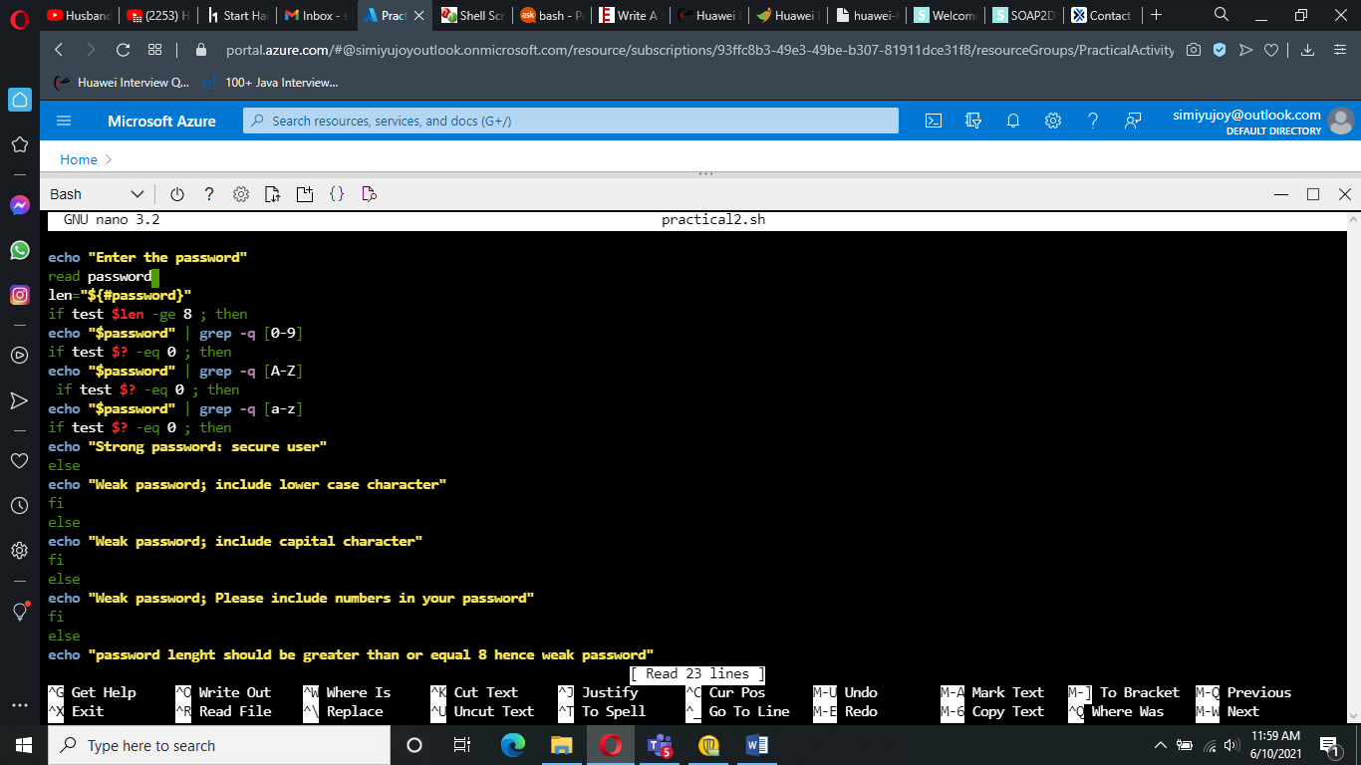

* The code above is shown below:

echo "enter the password"

read password

len="${#password}"

if test $len -ge **8** ; then

echo "$password" | grep -q [**0-9**]

 if test $? -eq **0** ; then

  echo "$password" | grep -q [A-Z]

  if test $? -eq **0** ; then

echo "$password" | grep -q [a-z]

if test $? -eq **0** ; then

echo "Strong password"

  else

 echo "weak password include lower case char"

 fi

else

echo "weak password include capital char"

  fi

 else

echo "please include the numbers in password it is weak password"

fi

else

  echo "password lenght should be greater than or equal 8 hence weak password"

fi

* Below shows different passwords formats tried with their different error messages until user gets the password entered accepted as a strong password.

